**Smart Canteen Management System**

**Dr.K.Srinivasa Rao 1, P.Praneetha 2, G.S.Prabhu Kiran 3, P.Vasu 4, P.Vasantha 5, N.Charles Bunny 6**

**1**Assistant Professor, Department of Artificial Intelligence and Machine Learning,

Sri Vasavi Engineering College(A),Pedatadepalli,Tadepalligudem

**2** Department of CSE, Sri Vasavi Engineering College(A),Pedatadepalli, Tadepalligudem

**3** Department of CSE, Sri Vasavi Engineering College(A),Pedatadepalli, Tadepalligudem

**4** Department of CSE, Sri Vasavi Engineering College(A),Pedatadepalli, Tadepalligudem

**5** Department of CSE, Sri Vasavi Engineering College(A),Pedatadepalli, Tadepalligudem

**6** Department of CSE, Sri Vasavi Engineering College(A),Pedatadepalli, Tadepalligudem

**Email**: [srinivasarao.cse@srivasaviengg.ac.in](mailto:srinivasarao.cse@srivasaviengg.ac.in.m)

**Corresponding authors Email****:** [praneethap03@gmail.com](mailto:praneethap03@gmail.com) ,

[kiran97051@gmail.com](mailto:kiran97051@gmail.com) ,

[pattipativasu3@gmail.com](mailto:pattipativasu3@gmail.com) ,

[vasanthapolinati30@gmail.com](mailto:vasanthapolinati30@gmail.com),

[n.charlesbunny888@gmail.com](mailto:n.charlesbunny888@gmail.com)

**Abstract:**

The "Smart Canteen Management System" project aims to revolutionize the traditional canteen experience in educational institutions by leveraging modern technologies and automation. This system offers an efficient and convenient approach to managing canteen operations, enabling seamless transactions,improved resource utilization, and enhanced user experience for both faculty members and students.It will bring numerous benefits, including reduced waiting times, increased efficiency, improved inventory management, and enhanced user satisfaction. Every person eats at least twice or three times daily, therefore during that time it can aid them without delaying their schedule.This solution is made to be adaptable and may be customized to meet the particular needs of various educational institutions. It aims to provide a modern and technologically advanced dining experience in the school or college cafeteria, making it more convenient and adaptable to the specific needs of each institution.

**Keywords:** Canteen management , Educational Institutions , Web Technologies ,Django framework.

**1. INTRODUCTION**

We're all searching for creative methods to streamline our daily routines in the hectic world of education today, where every second counts. We need efficiency and convenience, whether we're racing to lectures, balancing assignments, or attempting to fit in extracurricular activities. The "Smart Canteen Management System" is ready to change how we perceive school and college canteens at this point.

Consider the issues that are all-too-common in traditional canteens: the never-ending lineups, the paper-based processes, and the ongoing battle to keep things moving efficiently. These problems affect not just the personnel and students, but also the general effectiveness of our institutions and universities. The "Smart Canteen Management System" is on a mission, and that's the thrilling part.

This groundbreaking initiative isn't just about advancing technology; it's focused on enhancing the lives of students on campus. Picture a time when your canteen visits are all about efficiency and technology. Imagine a future where you can say goodbye to those frustratingly long lines, and welcome an effortless, enjoyable dining experience.

With the "Smart Canteen Management System," it's all about putting your needs first, ensuring that your time in the canteen is not just efficient but also filled with satisfaction. This marks a step towards making dining on campus more enjoyable and efficient, guaranteeing that every moment spent in the cafeteria is time well invested. So, brace yourself for a future of campus dining where convenience and efficiency reign supreme.

**2. LITERATURE SURVEY**

The most important step in the software development process is the literature review. This will describe some preliminary research that was carried out by several authors on this appropriate work and we are going to take some important articles into consideration and further extend our work.

# M. Ambika, Saravana Kumar R, Sandhya S Nair, and Ranjith Kumar S, published in the International Journal of Innovative Technology and Exploring Engineering (IJITEE) under Blue Eyes Intelligence Engineering & Sciences Publication, a notable topic of exploration is the "Cashless Canteen System." This system presents a considerable advantage in that its effectiveness is not confined by the scale or size of the business. Unlike traditional models, this innovative platform proves adaptable to both small-scale and large-scale enterprises. However, it's worth noting that this system has a limitation - the absence of a liquid cash payment option.

# 

# Suman Chatterjee and Manish Kumar Thakur present the "Smart Collage Management System (IJERT)." This Android-based application offers a more user-friendly and efficient way for college administrators, faculty, and students to handle various tasks. One of its key advantages is reducing the need for extensive paperwork. While this excerpt doesn't delve into specific details, it emphasizes the system's commitment to enhancing the college experience by simplifying various academic and administrative processes.

# Ketan Bhekare, Chinmay Karandikar, Ganesh Kamble, and Varsha Wangikar, in their research paper titled "Smart Canteen System," published in the Journal of Emerging Technologies and Innovative Research (JETIR) in April 2019, have highlighted the system's efficiency compared to manual processes. Their study reveals that the online-based system not only saves time but also enhances the overall convenience for customers who regularly order food from the canteen. Although this excerpt provides a concise overview, it emphasizes the significance of the system's efficiency and customer satisfaction.

# B. Kale, Ruchika K. Balwade, and Vipin B. Gawai from All India Shri Shivaji Memorial Society’s College of Engineering, Pune, India, and published in the SAMRIDDHI Volume 12, Special Issue 2 in 2020, they present an "Online Food Ordering System for College Canteen." Their main goal is to create an Android app that addresses the common issue of students having to wait in long queues to place their food orders and then wait again for their deliveries. This system aims to enhance the overall efficiency and convenience of the food ordering process for college students, making their dining experience more pleasant and time-saving.

# Mr. Ram Krishna Singh, Km. Anjali, Madhavi Tripathi, Ashi Sachan, and Antima Gupta, in their paper featured in the May 2023 issue of the International Journal for Research in Applied Science & Engineering Technology (IJRASET), introduce the "E-Canteen System." This innovative system is designed to benefit both customers and administrators. It aims to provide excellent service to customers while also boosting sales and attracting more business for administrators. While this summary provides a concise overview, it underscores the system's dual focus on enhancing customer experience and fostering business growth within the canteen context.

# Dr. C. Mahiba, Rajashekar V, S Dhanush, Santosh Kumar, and Sharath Chandra BR, in their paper published in the June 2023 issue of the International Journal of Research Publication and Reviews, introduce the "College E-Canteen Management System." This innovative system brings valuable benefits to the canteen management team, including a reduction in paper usage and the elimination of the need for additional personnel at the billing counter.

**3. EXISTING SYSTEM**

The current canteen management systems are falling short in keeping up with the changing needs of students and faculty members. They often lead to frustratingly long waiting times, relying heavily on manual processes. This not only results in inefficient use of resources but also provides a less than ideal user experience. Students and faculty members, who require meals several times a day, find themselves hampered by the time-consuming procedures for ordering, making payments, and waiting for their food. This inconvenience doesn't just affect individual productivity; it also has a negative impact on the overall quality of the campus experience.

1. **Manual Hassles**: The way canteens are managed right now involves a lot of manual work. This leads to delays and inefficiencies in serving students and faculty.
2. **Never-Ending Wait**: Ordering food, making payments, and waiting for the meal often takes too long. This can disrupt the schedules of both students and faculty, causing frustration.
3. **User-Friendly Shortage**: The existing systems don't offer a great user experience. They fail to meet the needs of those who rely on the canteen multiple times a day, affecting their satisfaction.
4. **Resource Mismanagement**: Resources like food and staff are often not used effectively. The current systems struggle to allocate these resources efficiently, leading to waste and extra costs.
5. **Campus Vibe Disrupted**: All these inconveniences not only impact individuals but also affect the overall campus experience, making it less enjoyable for everyone.
6. **Flexibility Gap**: The current systems are not very flexible. Campuses find it hard to adapt the canteen operations to their unique needs, leading to less-than-optimal service
7. **Service Not Up to the Mark**: Due to this lack of adaptability, the quality of service often falls short, making the dining experience for students and faculty less enjoyable.

**4. PROPOSED SYSTEM**

1. **Modernizing canteen operations**:The "Smart Canteen Management System" is a cutting-edge approach to modernizing canteen operations at educational institutions.
2. **Leveraging Technology**: This system strives to improve the efficiency and user-friendliness of the canteen experience by adopting contemporary technologies and automation.
3. **Digital ordering and menu displays**: This cuts wait times and improves the whole eating experience by providing digital menus and the ease of placing orders online.
4. **Simplified Order Processing**: The system streamlines order processing and payments, resulting in speedy and hassle-free transactions.
5. **Real-time Transaction Tracking**: Users may keep track of their orders in real-time, guaranteeing correctness and transparency.
6. **Effective Time Slot Reservation**: Time slot management improves the organization of the canteen and decreases crowding and wait times.
7. **Feedback and Ratings System**: An evaluation system makes sure ongoing improvement, giving staff and students a vote in how they want to eat.

**System architecture**

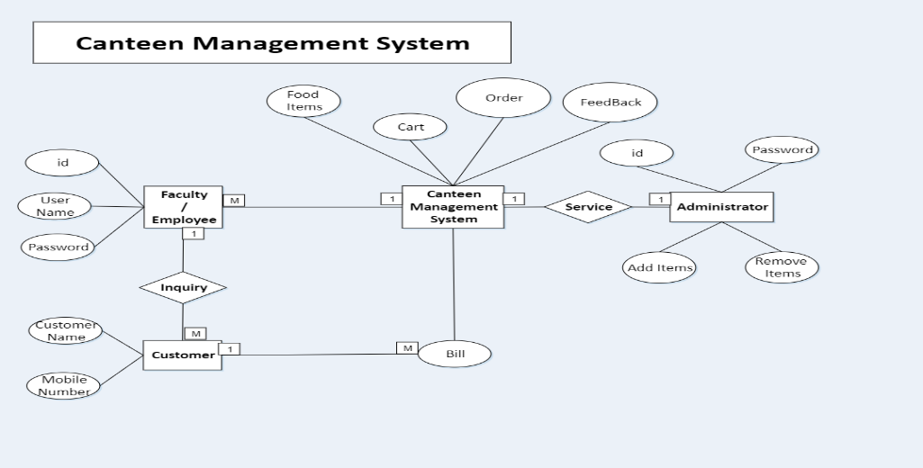

**Index view**

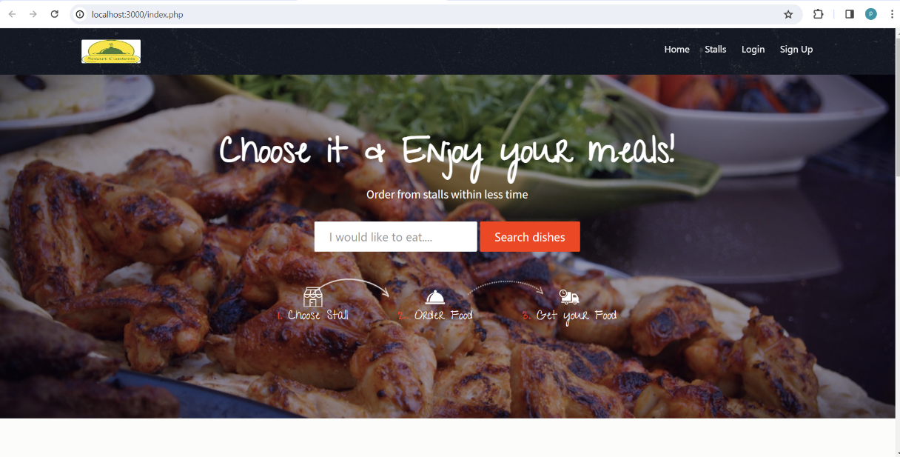

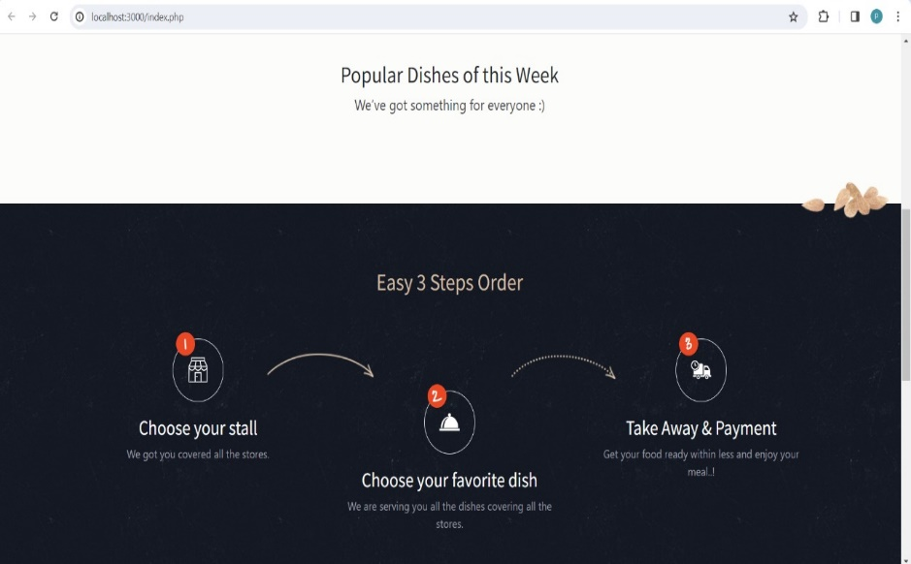

**Login form**

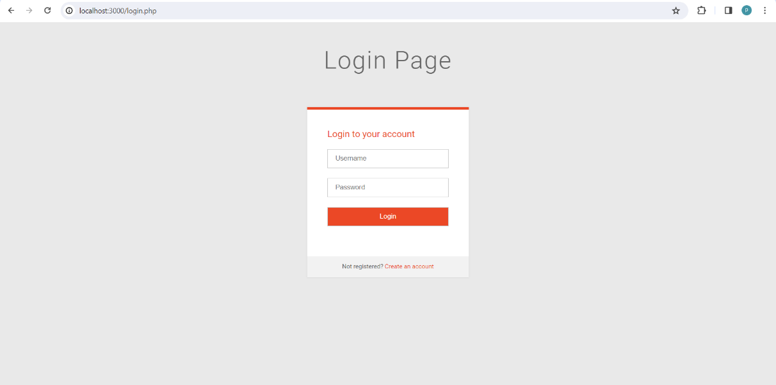

**Admin-side view**

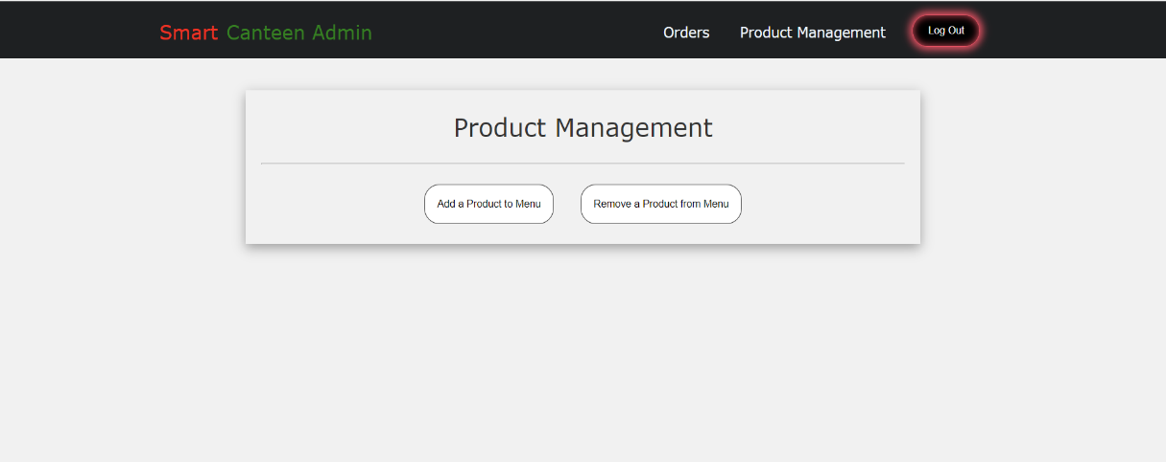

**Registration page**

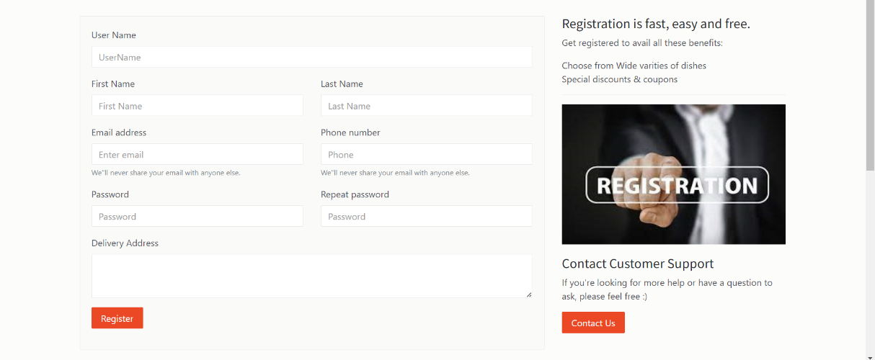

**Client-side view(Dishes)**

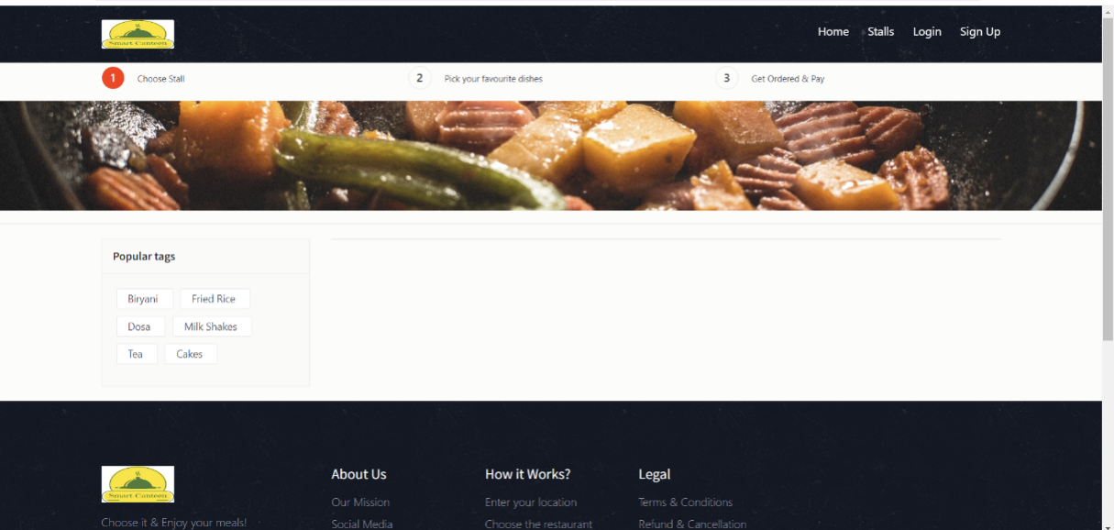

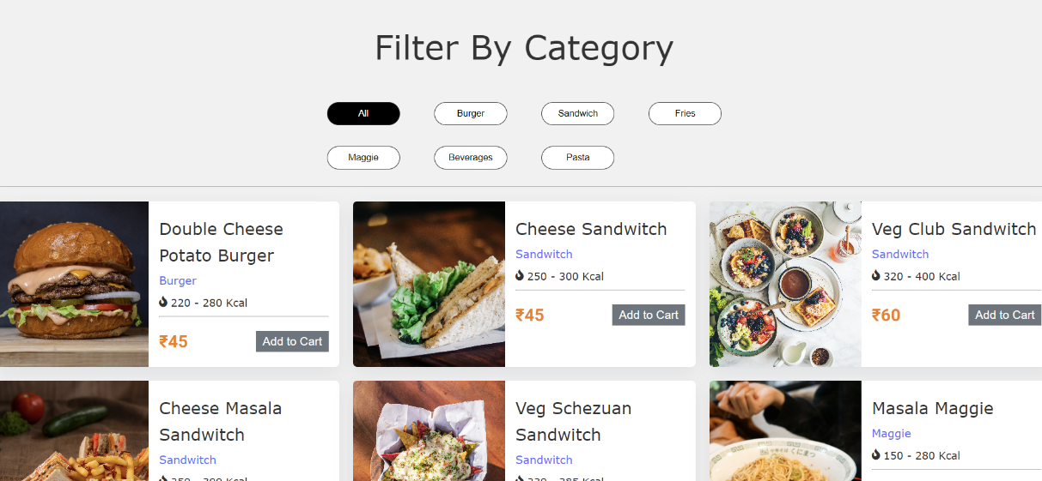

**5. EXPERIMENTAL RESULTS**

Waiting times were effectively decreased, order accuracy was improved, resources were optimally allocated, and customer happiness was increased with the "Smart Canteen System" for educational institutions. The incorporation of time slot bookings and feedback mechanisms boosted the canteen's operations' efficiency and convenience.

**RESULT IS DISPLAYED**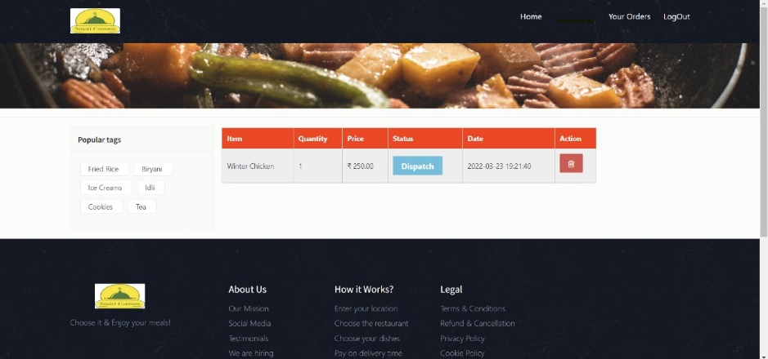

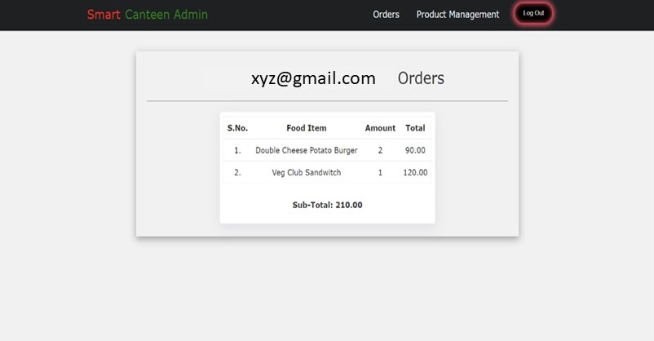

**Explanation:** From the above window, we can find the result is declared and giving assurance for a better smart canteen system in institutions.

**6. CONCLUSION**

Finally, the "Smart Canteen Management System" project seeks to usher in a new era of canteen management in educational institutions by utilizing the strength of contemporary technology and automation. By streamlining transactions, optimizing resource allocation, and boosting the overall experience for both staff members and students, this ground-breaking solution presents a practical and user-friendly approach to managing cafeteria operations. Several advantages, including shorter wait times, increased effectiveness, simplified inventory management, and higher user satisfaction, are promised as a result of its implementation. Every person needs many meals a day, thus this method becomes a vital resource for preventing schedule disruptions caused by lengthy lines and delays. Additionally, it provides a flexible and scalable system that enables customization to meet the specific needs of many academic institutions. By doing this, it prepares everyone for a contemporary, cutting-edge, and enjoyable canteen experience.

It can also be expanded as:

The "Smart Canteen Management System" could be expanded to include meal customization, dietary tracking, feedback and ratings, mobile payment integration, allergen alerts, real-time inventory management, integration with kitchen equipment, discounts and loyalty programs, multilingual support, and a food donation feature. The user experience, efficiency, and social responsibility would all be improved by these additions.

**Declaration**

1. All authors do not have any conflict of interest.
2. This technology "has the potential to modernize canteen operations, making them more effective and user-friendly, ultimately improving the dining experience for faculty and students," according to the report.

**References**

[1] Ms. S.A.Patil*1, Janhavi. B. Sutar*2 , Sakshi. Y(2021) “AUTOMATED CANTEEN MANAGEMENT SYSTEM”- , International Research Journal of

Modernization in Engineering Technology and Science , Volume:03.

[2] Ms.Minu, Kowshik reddy, Sumanth Ashik Teja (2018) “ONLINE CANTEEN SYSTEM” Computer Science and Engineering ,SRM Institute of Science and

Technology, Ramapuram, Chennai, India , 2018 JETIR October 2018, Volume 5, Issue 10.

[3] Tazeen Khan, Daniel Yunus “Cloud Based Canteen Management System” , International Journal for Research in Engineering Application & Management

(IJREAM), Vol-02, Issue 08, Nov 2016.

[4] Rupali B. Kale* , Ruchika K. Balwade, Vipin B. Gawai(2020) “Online Food Ordering System for College Canteen”, RESEARCH ARTICLE SAMRIDDHI

Volume 12, Special Issue 2.

[5] Shourya Pradhan, Shubham Jain ,Shubhanshu Pratap Singh, Yash Gupta (2019)“Canteen Management App”,International Journal of Information Sciences and

Application (IJISA). ISSN 0974-2255, Vol.11, No.1, 2019.

[6] Arfa Hassan , Salma Rashid , Raheela Khan , Shazia Saqib “Automated Food Ordering System”, Lahore Garrison University, Lahore, Pakistan. 2University of

Management and technology Lahore, LGU Research Jounral for Computer Sciences & IT Vol. 2 Issue 4, October - December 2018.

[7] N. Durga Swathi & T. Durga “ONLINE CANTEEN FOOD ORDERING SYSTEM”, VSM College of Engineering, East Godavari District, Andhra Pradesh,

India, AEGAEUM JOURNAL Volume 8, Issue 8, 2020 ISSN NO: 0776-3808.

[8] B Muniraja , J Rajanikanth - In - Time Billing Process for Canteen Management System - International Journal of Emerging Trends in Engineering Research

(IJETER), Vol. 3 No.6, Pages : 200 - 203 (2015) .

[9] Ashwini J, Ayisha Shetty, Chaithra, Lasya K Rao,Asst. Prof. Ramya D Shetty(2018) “Automated Food Ordering System”, International Journal of Scientific &

Engineering Research Volume 9.